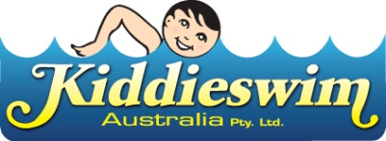

July 2026
Public Swimming Timetable

Currently, we are unable to provide a school holiday public swimming timetable.
We are currently closed due to work being undertaken by Mornington Secondary College.

A timetable will be uploaded here as soon as we can provide one.

If you have any questions, please contact us on 5976 1107

We apologise for any inconvenience

www.kiddieswim.com.au

